Which of the following is incorrect statement for the given reaction?
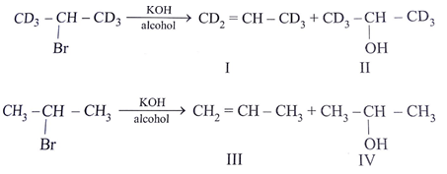
Formation of III involves $E_{1}$ reaction in given reaction
a) Rate of formation of II and IV would be identical
b) Rate of formation of I would be slower than that of III
c) Formation of I would show primary isotope effect
d) Formation of III involves $E_{1}$ reaction
ANSWER: D

Which of the following statements is correct for alkyl halide?
a) Alkyl halide will always show SN1 mechanism
b) As branching at carbon increases, $E_{1}$ mechanism is favoured as compared to SN1 mechanism
c) In unimolecular reaction, increasing the temperature donot favours $E_{1}$ mechanism
d) In most unimolecular reactions of alkyl halide $E_{1}$ reaction is favoured over SN1 reaction
ANSWER: B
Tertiary alkyl halides follow _____________ mechanism.
A. $SN^{1}and E_{2}$
B. $E_{1} and E_{2}$
C. $SN^{1} and E_{1}$
D. $SN^{2} and E_{2}$
ANSWER: C
Secondary alkyl halides follow _____________ mechanism.
A. $SN^{1}and E_{2}$
B. $E_{1} and E_{2}$
C. $SN^{1} and SN^{2}$
D. Both B and C
ANSWER: D
$E_{1}$ stands for ______________ elimination.
A. Bimolecular
B. Unimolecular
C. Trimolecular
D. Molecular
ANSWER: B
The rate of $E_{1}$ reaction depends upon:
A. The concentration of substrate
B. The concentration of nucleophile
C. The concentration of substrate as well as the nucleophile
D. Base the concentration of substrate as well as a nucleophile
ANSWER: A
When 2-methyl-2-chloro propane react with KOH in polar solvent.
A. $SN^{1}$
B. $SN^{2}$
C. $E_{1}$
D. $E_{2}$
ANSWER: C
Which of the following is an example of $E_{1}$ reaction?
A. 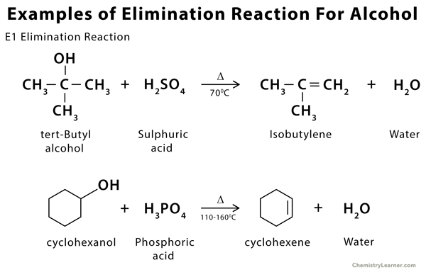
B. 
C. 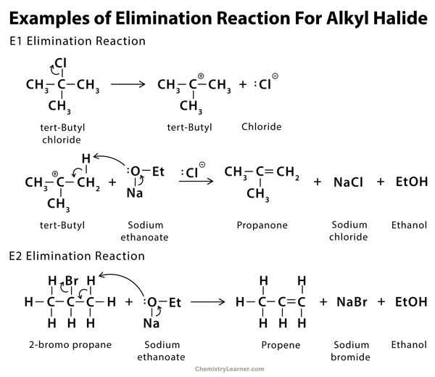
D. All of these
ANSWER: D

Which of the following is an example of $E_{2}$ reaction?
A. 
B. 
C. 
D. All of these
ANSWER: C
Which alkyl halide can give both $E_{1}$ and $E_{2}$ reaction?
A. Primary alkyl halide
B. Secondary alkyl halide
C. Tertiary alkyl halide
D. All of these
ANSWER: B
When 2-chloro propane react with KOH in polar solvent.
A. $SN_{1}$
B. $SN_{2}$
C. $E_{1}$
D. $E_{2}$
ANSWER: C
In which of the following reactions mechanism, the $1^{st}$ step is same?
A. $E_{1} and E_{2}$
B. $SN_{1} and SN^{2}$
C. $SN_{1} and E^{1}$
D. $SN_{2} and E^{2}$
ANSWER: C
Secondary alkyl halides undergo $E_{1}$ mechanism when ___________ solvent is used.
A. Neutral
B. Polar
C. Non-polar
D. Anhydrous alcohol
ANSWER: B
Which reaction is favored by weak base?
A. $E_{2}$
B. $E_{1}$
C. $E_{2}$ and $E_{1}$
D. $SN_{2}$
ANSWER: B
When ethyl chloride is heated with alcoholic potash, ____________ is formed.
A. Propane
B. Ethane
C. Ethene
D. Ethyne
ANSWER: C

